NYAST 2021 Annual Conference, Business Meeting & Elections
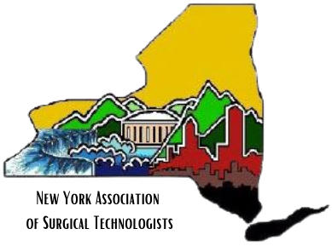
Saturday October 2, 2021
8am-3pm
Turning Stone Resort
5218 Patrick Rd, Verona, NY 13478
5 CEU's Anticipated Approval by AST
Annual Business Meeting and Elections will be held
Member/Non-Member $50/$60 At the door
Veterans $25
Students $10/20

A Limited number of rooms have been reserved
$189/night plus taxes
1-800-771-7711
to reserve- New York Association of Surgical Technologists room block

If you have an interest in the future of Surgical Technologists in New York, have been an AST member for one year (student membership counts!) and are currently certified (CST), please contact us for more information on how you can become involved. You can submit your Consent to Serve and Curriculum Vitae (links to these forms are on ny.ast.org) to the Credentialing Committee and to BoardNYAST@gmail.com.
ELECTIONS WILL BE HELD IN PERSON ONLY AT THE FALL 2021 CONFERENCE FOR THE FOLLOWING:
PRESIDENT
VICE PRESIDENT
SECRETARY
TREASURER
5 DIRECTORS
6 DELEGATES & 6 ALTERNATES FOR NATIONAL CONFERENCE
Any other questions, interest in running for the board, or interested in speaking, please email the board @ BoardNYAST@gmail.com
THERE WILL BE NO REfuNDS GIVEN FOR ANY REASON DUE TO THE COST OF PLANNING THE EVENT!

3 Objectives-
1. Members will learn about legislative initiatives within NY and AST as a whole
2. Members will gain an understanding about fire safety and its importance
3. Members will learn about cardiopulmonary testing that they may not know about prior to surgery.

Annual Conference, Business Meeting & Elections
Saturday October 2, 2021
Turning Stone Resort, Verona NY

AGENDA
0700-0750 Registration & Breakfast
0750-0800 Welcome Announcements
Emily Runions CST, FAST, NYAST President

0800-0850 Preoperative Pulmonary Assessment
Dr. Viren Kaul

0900-0950 Business Meeting, Candidate Statements

0950-1000 Break

1000-1050 Laparoscopic Simulation? Why is it so important anyways?
Mel Angelasanti CST, CSFA, Surgical Science

1100-1150 Legislative Updates. What’s New and What’s Next?
Josephine Colacci, Esq. AST Legislation Representative

1150-1215 Voting

1215-1315 Lunch and Exhibits

1315-1405 Fire in the OR!
Joseph Charleman, CST, CSFA, FAST

1415-1445 Business Meeting & Results

1445-1450 Break

1450-1540 Open Forum, Ask us Anything!
NYAST Board of Directors, AST Representatives, NBSTSA Representatives

1540-1550 Raffles, Giveaway’s, Certificate of Attendance

